SIMATS ENGINEERING

ASSESSMENT TOOL 1

COURSE NAME: COMPUTER NETWORKS COURSE CODE: CSA0706

COURSE OUTCOME COVERED
CO5:
Design network topologies star, mesh, bus, and hybrid using networking devices, transmission media, and cabling standards
(BL2,BL5)

Assessment Tool Weightage: 40%

QUESTIONS: 3 Total Marks:30
Annexure A

Constraint-Based Problem Solving

Code of Conduct:
I RUCHITA.S (192572081) certify that this submission is my original work and that I have adhered to the guidelines specified for this assessment.
I understand that any violation of academic integrity rules will result in disciplinary action.
Signature of the student:

RUCHITA.S
Annexure A

Constraint-Based Problem Solving
- A multinational company is opening a new branch office in a remote rural location where high-speed wired internet is unavailable. The office must support cloud-based applications, video conferencing, and secure communication with the headquarters. The company has a limited budget for connectivity but requires uninterrupted business operations. As a network engineer, recommend a suitable internet connection, networking devices, and security mechanisms. Justify your recommendations by considering bandwidth limitations, reliability, cost, and future scalability
SOLUTION:

PROBLEM UNDERSTANDING
The company is opening a branch in a remote rural location where high-speed wired Internet is unavailable. The network must support cloud applications, video conferencing, and secure communication with headquarters. The solution must also be affordable and reliable.

CONSTRAINTS

Constraint | Requirement
Location | Remote rural area
Internet | High-speed wired Internet unavailable
Applications | Cloud applications and video conferencing
Security | Secure connection to headquarters
Budget | Limited
Reliability | Uninterrupted operation
Scalability | Should support future expansion

RECOMMENDED SOLUTION
Internet Connection:
Use a 4G/5G wireless broadband connection as the primary Internet connection. If cellular coverage is unreliable, use satellite Internet as an alternative.
Networking Devices:
- 4G/5G router
- Managed network switch
- Wireless access point
- Firewall/router
- UPS for network devices
Security:
- Site-to-site VPN between branch and headquarters
- Firewall
- WPA3 for Wi-Fi
- Strong user authentication
- Network segmentation using VLANs
NETWORK DIAGRAM:
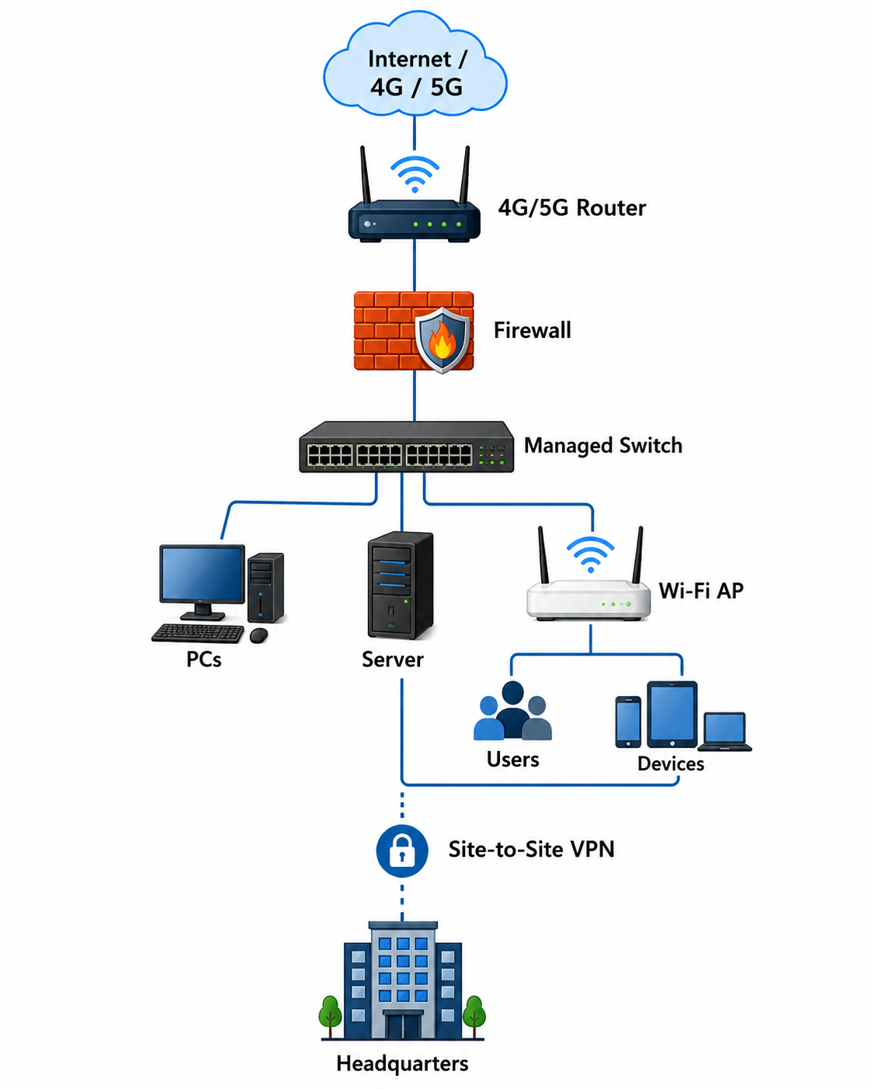

JUSTIFICATION
1. Bandwidth:
4G/5G provides sufficient bandwidth for cloud applications and video conferencing where wired broadband is unavailable.
2. Reliability:
A backup connection such as satellite or a secondary cellular connection can be used if the primary connection fails.
3. Cost:
A wireless broadband solution avoids the high cost of installing wired infrastructure in a remote location.
4. Security:
VPN encryption protects communication between the branch and headquarters. A firewall prevents unauthorized access.
5. Future Scalability:
A managed switch and scalable wireless network allow additional users and devices to be added later.

CONCLUSION
A 4G/5G-based network with firewall, VPN, managed switch, Wi-Fi access point, and backup connectivity provides a practical balance between bandwidth, reliability, cost, security, and scalability.
- A university plans to provide campus-wide wireless internet access for more than 3,000 students across classrooms, laboratories, libraries, and hostels. The network must support a large number of simultaneous users while minimizing signal interference and ensuring secure access. Due to budget constraints, only a limited number of wireless access points can be deployed. Analyze the requirements and propose an efficient wireless network design, including access point placement, frequency band selection, and authentication methods. Explain how your solution balances coverage, performance, security, and cost.
SOLUTION:

PROBLEM UNDERSTANDING
The university needs campus-wide wireless access for more than 3,000 students across classrooms, laboratories, libraries, and hostels. The main challenges are high simultaneous-user demand, interference, security, limited access points, and budget constraints.

CONSTRAINTS

Constraint | Requirement
Users | 3,000+ students
Coverage | Classrooms, labs, libraries, hostels
Capacity | Many simultaneous users
Interference | Must be minimized
Security | Secure authentication
APs | Limited number
Budget | Cost-effective design

RECOMMENDED DESIGN
Use a centrally managed Wi-Fi network with strategically positioned high-capacity access points.

Access Point Placement
Access points should be placed in:
- Classrooms → one or more APs based on user density
- Laboratories → high-capacity APs
- Libraries → APs positioned to cover study areas
- Hostels → APs distributed floor-wise
- Common areas → APs positioned to cover high-user-density zones
Instead of simply maximizing coverage, AP placement should focus on user density and capacity.

Frequency Band Selection

Band | Use
2.4 GHz | Longer range and better wall penetration
5 GHz | Higher performance and more available channels
6 GHz | Suitable for newer compatible devices and high-capacity environments
Use 5 GHz/6 GHz for high-density areas whenever compatible devices are available, while 2.4 GHz can provide additional coverage.

Authentication
Use:
- WPA3-Enterprise
- 802.1X authentication
- Central authentication server such as RADIUS
- Individual student credentials

NETWORK DIAGRAM

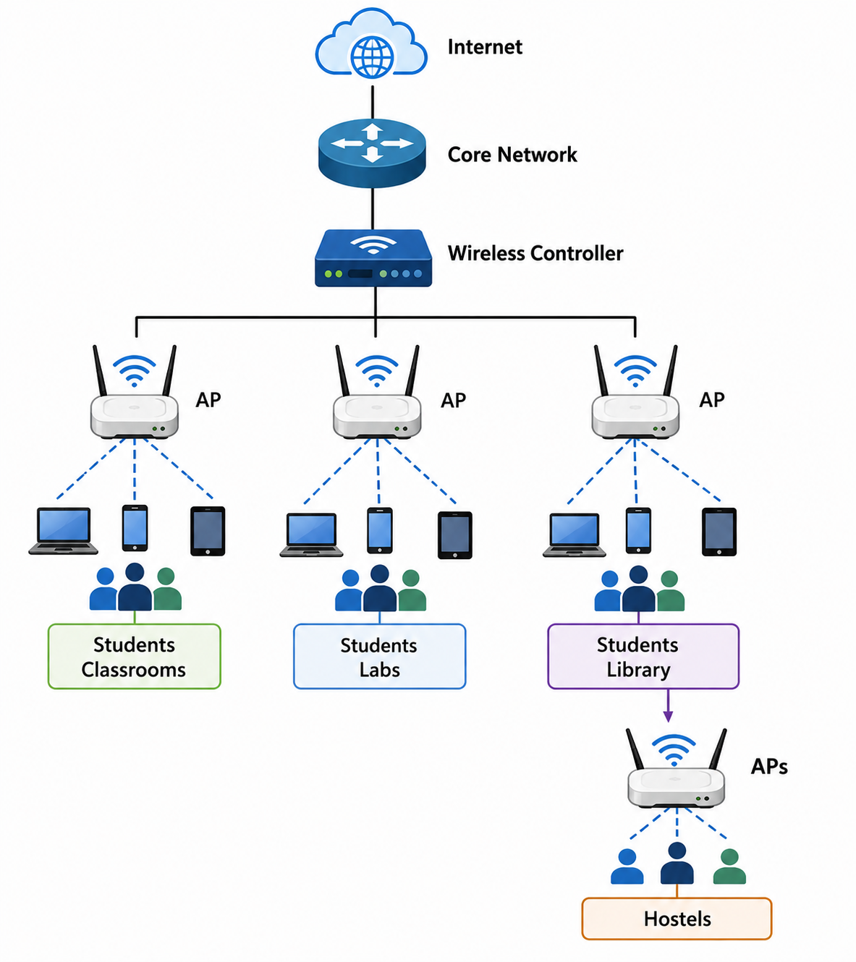

Interference Reduction
- Use proper channel planning.
- Avoid overlapping channels where possible.
- Prefer 5 GHz/6 GHz in high-density locations.
- Adjust AP transmit power.
- Avoid placing too many APs close together.
- Monitor channel utilization.

Balancing the Constraints
Coverage: Strategic AP placement covers required buildings.
Performance: High-capacity APs and 5/6 GHz reduce congestion.
Security: WPA3-Enterprise and individual authentication prevent unauthorized access.
Cost: Instead of installing a very large number of APs, high-capacity APs are strategically positioned according to user density.

CONCLUSION
A centrally managed, high-density wireless network with strategic AP placement, appropriate frequency-band selection, channel planning, and WPA3-Enterprise authentication provides a good balance between coverage, performance, security, and cost.
- A financial institution is upgrading its internal computer network to improve cybersecurity while allowing employees to access sensitive customer information and online banking services. The organization must comply with strict security policies without significantly affecting network performance or increasing operational costs. Design a secure network architecture by selecting appropriate network segmentation techniques, firewall deployment, authentication methods, and intrusion detection mechanisms. Justify your design by considering the constraints of security, performance, compliance, and budget.

SOLUTION:

PROBLEM UNDERSTANDING
The financial institution needs stronger cybersecurity while employees still need access to sensitive customer information and online banking services. The design must satisfy security, performance, compliance, and budget constraints.

CONSTRAINTS

Constraint | Requirement
Security | Very high
Sensitive data | Must be protected
Performance | Should not be significantly reduced
Compliance | Must follow strict security policies
Cost | Operational cost should remain controlled
Access | Employees need controlled access

NETWORK DIAGRAM:

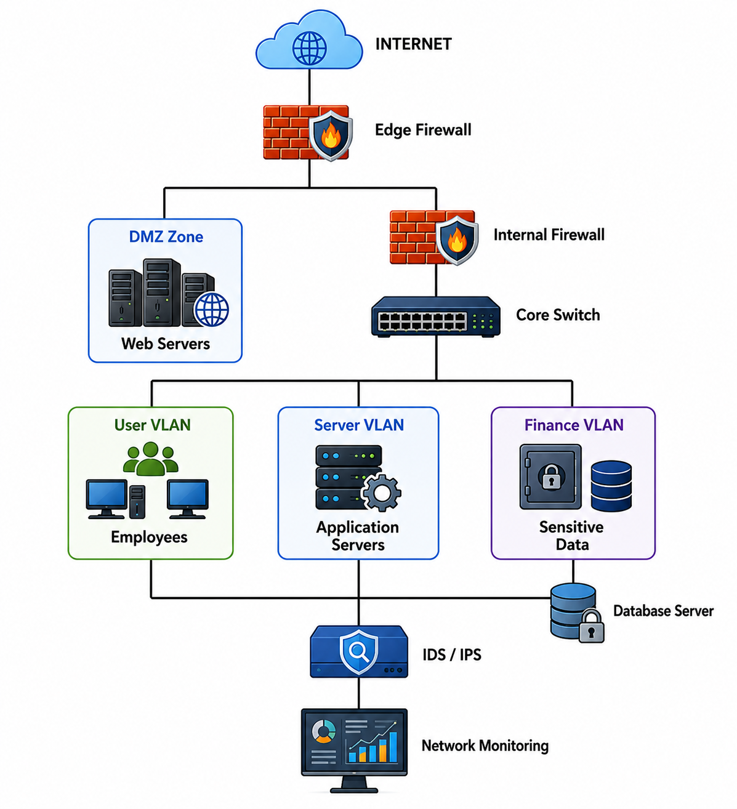

1. Network Segmentation
Divide the network into separate VLANs:
- User VLAN – employee computers
- Server VLAN – application servers
- Finance VLAN – sensitive financial systems
- Management VLAN – network administration
- Guest VLAN – external/guest users
This prevents an attacker who compromises one section from easily accessing the entire network.

2. Firewall Deployment
Use firewalls:
- At the Internet gateway
- Between external/DMZ and internal networks
- Between sensitive internal network segments where required
Firewall rules should allow only necessary traffic.

3. Authentication
Use:
- Multi-factor authentication (MFA)
- Strong passwords
- Role-based access control
- 802.1X for network access
- Individual user accounts
Employees should receive only the permissions required for their jobs.

4. Intrusion Detection and Prevention
Deploy IDS/IPS to:
- Monitor suspicious traffic
- Detect attacks
- Identify unusual network behavior
- Block known malicious traffic where IPS prevention is enabled
- Generate security alerts

5. Data Protection
Sensitive customer information should be protected using:
- Encryption
- Secure protocols such as HTTPS/TLS
- Access control
- Regular backups
- Secure database access

CONSTRAINT-BASED JUSTIFICATION

Security
Segmentation, firewalls, MFA, and IDS/IPS provide multiple layers of protection.

Performance
Traffic can be controlled using VLANs and firewall rules without routing all internal traffic through unnecessary security bottlenecks.

Compliance
Access control, authentication, monitoring, and logging help the organization enforce strict security policies and maintain audit records.

Budget
Use centralized security management and existing network infrastructure where possible instead of deploying unnecessary hardware at every location.

CONCLUSION
The recommended architecture uses network segmentation, layered firewalls, MFA, role-based access control, and IDS/IPS. This provides strong protection for sensitive financial information while maintaining acceptable performance and controlling operational costs.

RUBRICS FOR CALCULATION

Criteria | Weightage (%) | Exemplary (4) | Proficient (3) | Developing (2) | Beginning (1)
Understanding of Problem & Constraints | 20% | Clearly  identifies all  constraints and fully  understands the problem requirements | Identifies most constraints with minor  gaps in understanding | Identifies some constraints but misses key  aspects | Shows little or no understanding of constraints or problem
Problem Decomposition | 15% | Breaks problem into logical, well-structured sub-problems effectively | Breaks problem into sub-parts with some logical  flow | Attempts decomposition but lacks clarity or structure | No clear decomposition of the problem
Application of Constraints in Solution | 20% | Applies all constraints  correctly and consistently in solution design | Applies most constraints correctly with minor errors | Applies some constraints but with noticeable errors | Fails to apply constraints appropriately
Logical Reasoning & Strategy | 15% | Uses strong, clear, and efficient reasoning  strategies | Uses generally sound reasoning with minor gaps | Reasoning is partially correct but inconsistent | Reasoning is unclear or incorrect
Solution Accuracy & Feasibility | 15% | Solution is fully correct, feasible, and optimized | Solution is mostly correct and feasible | Solution has errors or is partially  feasible | Solution is incorrect or not feasible
Creativity & Innovation | 5% | Demonstrates highly  innovative and unique approach | Shows some creativity in approach | Limited creativity shown | No creativity; relies on basic or copied ideas
Clarity of Presentation | 10% | Solution is clearly presented with excellent organization and explanation | Presentation is clear with minor issues | Presentation  lacks clarity or organization | Poorly presented and difficult to understand

